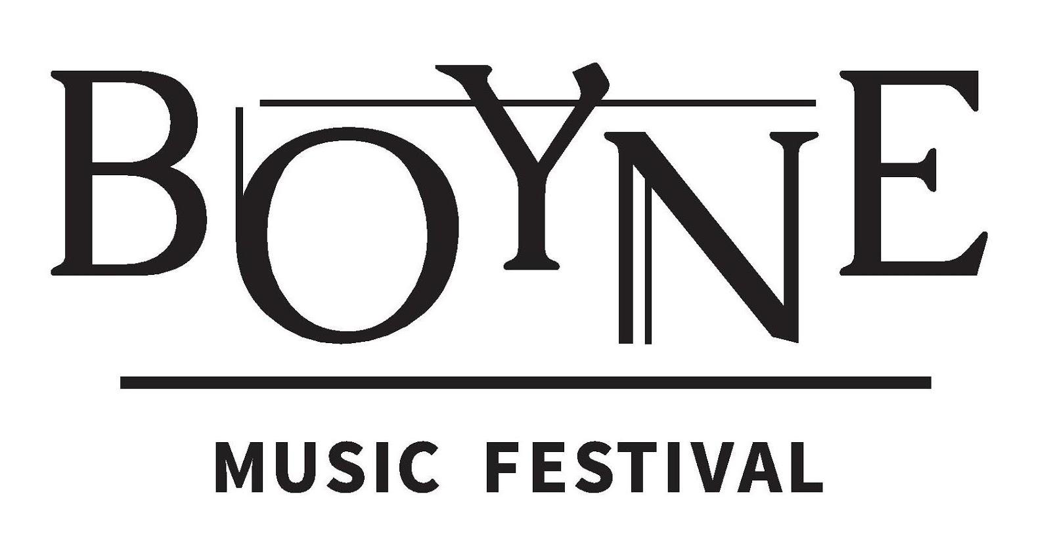

August 8th – 11th, 2019
Townley Hall, Drogheda

2019 Young Artist Programme

This summer’s Boyne Music Festival (BMF) will take place from 8th – 11th August 2019 at Townley Hall. The festival will feature four days of world-class chamber music, art, poetry and song, with performances by an impressive roster of international artists including Rita Manning, Robert Cohen, Carmen Flores, Chris Laurence, Margaret Plummer, Robin Panter, Vourneen Ryan, Aisling Manning, Julie-Anne Manning, Deirdre Brenner, Zoe Conway, John McIntyre and Neil McCarthy.
The organisers are delighted to invite young chamber ensembles to apply for participation in the 2019 BMF Young Artist Programme. Applications are welcome from string and piano chamber ensembles comprising of up to five performers, as well as voice and piano duos. Applicants must be 18 years or older.
Selected ensembles will be invited for masterclasses at Townley Hall from Wednesday 7th August – Sunday 11th August. Cellist Robert Cohen will coach string/piano ensembles on chamber music, and mezzo soprano Margaret Plummer will work with voice and piano duos on song repertoire. Each ensemble will receive three hours of coaching and will be offered food and accommodation at Townley Hall. Additionally, each ensemble will have the opportunity to perform at the festival on Sunday afternoon, August 11th in a programme which will feature all BMF Young Artists. Participants will receive weekend festival passes making it possible to attend all other BMF events.
Townley Hall was built in 1799 and is regarded as a masterpiece in the classical style of Francis Johnston, the foremost Irish architect of his day. Situated in the seclusion of expansive private grounds, it is an ideal location for focused artistic work. Masterclasses will take place in the house library which offers both a beautiful Steinway D and inspiring acoustics. Other nearby historical attractions in the Boyne Valley area include the ancient temple of Newgrange, a World Heritage Site, and the Battle of the Boyne site and visitor’s centre at Oldbridge House.
If accepted to the BMF Young Artist Programme, participants will be asked to pay a €150 administration fee per person to defray the costs of the programme.

Please complete the application form on the following page and send it together with all required supporting material by email to boynemusicfestival@gmail.com by 31st May, 2019.

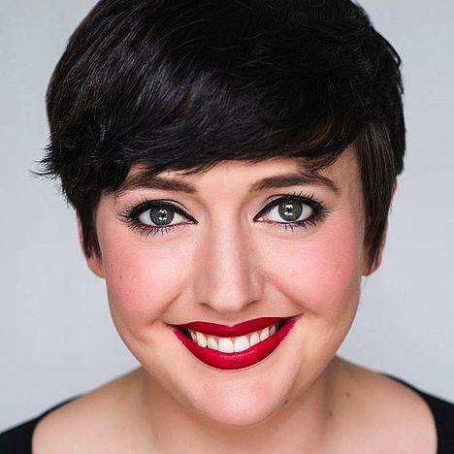
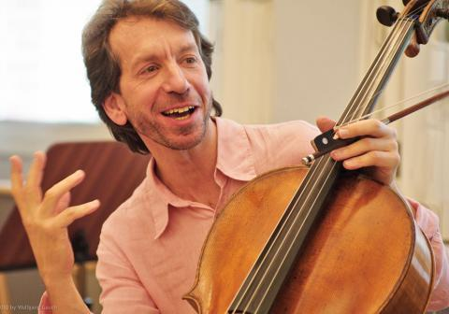
For further information please contact us by email at boynemusicfestival@gmail.com or visit www.boynemusicfestival.com

Boyne Music Festival Young Artist Programme 2019 | Application

Ensemble name: ......................................................................................................................

Performer name: Instrument: Date of Birth:
..................................................................... ...................................... ............................
..................................................................... ..................................... ...........................
...................................................................... ...................................... ............................
..................................................................... ..................................... ...........................
...................................................................... ...................................... ............................
Contact details for one ensemble member:
Name: ……................................................... Phone number: ………................................... ……….…….....
Email address: ........................................................................................................................................................
Home address: …………………………………………………………………....................................................…….........................
...................................................................................................................................................... ..... ...................

Proposed 30 minute concert programme: (You may offer more than one programme)
…………………………………………………………………………………………………....................................
…………………………………………………………………………………………………....................................
…………………………………………………………………………………………………....................................
…………………………………………………………………………………………………....................................

Required Supporting Material
Please provide the following additional materials:
- Ensemble biography
- Biography of each member of the ensemble
- Preferably, a recording of your ensemble (audio or video) – approx. 10 to 15min. in length.

Boyne Music Festival
Townley Hall, Slane Road, Drogheda, Co Louth, Ireland
www.boynemusicfestival.com | boynemusicfestival@gmail.com www.facebook.com/BoyneMusicFestival

