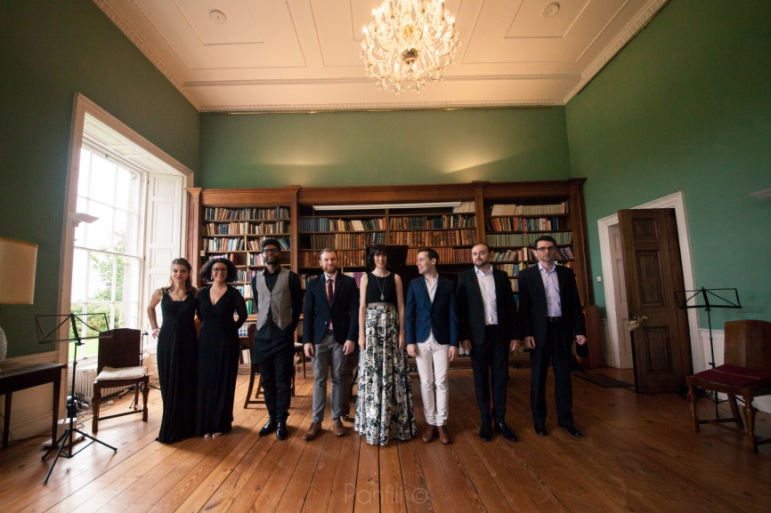
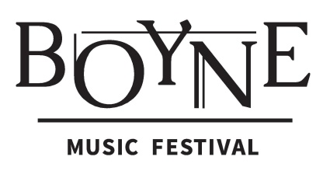

August 4th – 6th, 2017
Townley Hall, Drogheda

Young Artist Programme 2017

The fifth annual Boyne Music Festival will take place 4th - 6th August 2017 at Townley Hall in Drogheda. It will feature three days of world-class chamber music, art, poetry and song, with performances by an impressive roster of international artists including Rita Manning, Paul Cassidy, Jacqueline Thomas, Chris Laurence, Norma Winstone, John Parricelli, Aisling Manning, Julie-Anne Manning, Layla Claire, John Chest, Deirdre Brenner and Sholto Kynoch.

The organisers are delighted to invite young chamber ensembles to apply for participation in the 2017 Boyne Music Festival Young Artist Programme. Applications are welcome from voice and piano duos, vocal chamber music ensembles and instrumental chamber music ensembles comprising of up to four performers. Applicants must be 18 years or older.

Selected ensembles will be invited for a masterclass residency with Boyne Music Festival Artists at Townley Hall from Saturday, July 29th to Sunday, July 30th. Tutors this summer include violinist Rita Manning, soprano Layla Claire, baritone John Chest and pianist Deirdre Brenner. Each ensemble will receive two hour-long song and/or chamber music coaching sessions per day and all food and accommodation over the weekend will be provided. Additionally, each ensemble will have the opportunity to perform at the festival on Sunday, August 6th in a programme featuring all BMF Young Artists. They will also receive festival passes making it possible to attend all festival events.

Townley Hall was built in 1799 and is regarded as a masterpiece in the classical style of Francis Johnston, the foremost Irish architect of his day. Situated in the seclusion of expansive private grounds, it is an ideal location for a masterclass weekend. Coaching sessions take place in the house library which offers both a beautiful Steinway D and inspiring acoustics. Further rooms throughout the house will be made available for private practice.

If accepted to the BMF Young Artist Programme, participants will be asked to pay a €100 administration fee to defray the costs of the programme.

For more information please contact us by email at boynemusicfestival@gmail.com or visit www.boynemusicfestival.com.

Please complete the application form on the following page and send it together with all required supporting material by email to boynemusicfestival@gmail.com by May 1st.

Boyne Music Festival Young Artist Programme 2017 | Application

Ensemble name: .......................................................................................................................................

Performer name: Instrument: Date of Birth:

............................................................................... ...................................... ....................................

............................................................................... ...................................... ....................................

............................................................................... ...................................... ....................................

............................................................................... ...................................... ....................................

Contact details for one ensemble member:

Name: …….................................................................. Phone number: …………......................................

Email address: .......................................................................................................................................

Home address: ………………………………………………………………………………………………………………………………….

Proposed 20 minute concert programme: (You may offer more than one programme)

....................................................................................................................................................................

………………………………………………………………………………………………………………………………………………………………

………………………………………………………………………………………………………………………………………………………………

....................................................................................................................................................................

………………………………………………………………………………………………………………………………………………………………

Required Supporting Material

Please provide the following additional materials:

- Ensemble biography
- Biography of each member of the ensemble
- A recording of your ensemble (audio or video) – approx. 10 to 15min. in length

Boyne Music Festival
Townley Hall, Slane Road, Drogheda, Co Louth
www.boynemusicfestival.com | boynemusicfestival@gmail.com
www.facebook.com/BoyneMusicFestival

