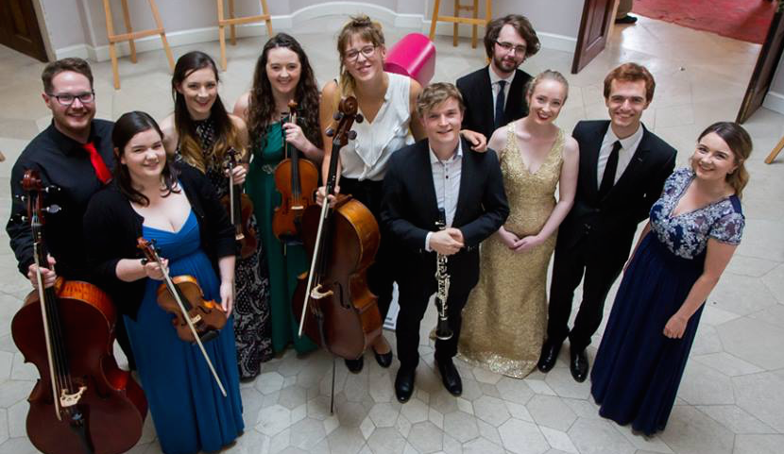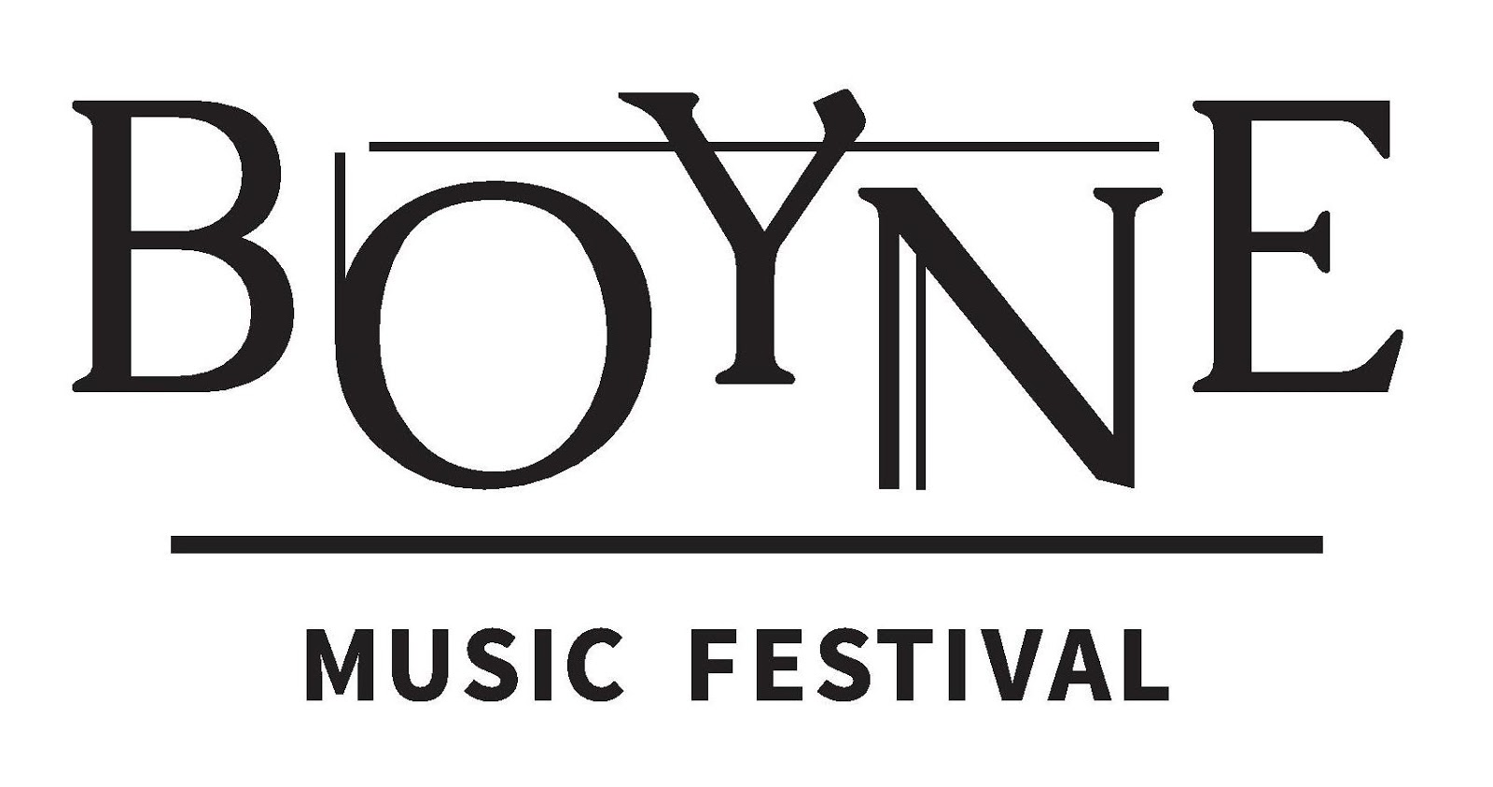

August 3rd – 5th, 2018
Townley Hall, Drogheda

2018 Young Artist Programme
The sixth annual Boyne Music Festival (BMF) will take place on 3rd - 5th August 2018 at Townley Hall in Drogheda, Ireland. It will feature three days of world-class chamber music, art, poetry and song, with performances by an impressive roster of international artists including Rita Manning, Paul Cassidy, Jacqueline Thomas, Chris Laurence, Robin Panter, John Parricelli, Dorrotya Lang, Aisling Manning, Julie-Anne Manning, Deirdre Brenner, Martin France and Frank Ricotti.
The organisers are delighted to invite young chamber ensembles to apply for participation in the 2018 Boyne Music Festival Young Artist Programme. Applications are welcome from string, wind and piano chamber ensembles comprising of up to five performers. Applicants must be 18 years or older.
Selected ensembles will be invited for a masterclass residency with Boyne Music Festival Artists at Townley Hall from Saturday, July 28th to Sunday, July 29th. Brodsky Quartet violist Paul Cassidy and cellist Jacqueline Thomas will tutor selected ensembles. Each ensemble will receive two hour-long chamber music coaching sessions per day and all food and accommodation over the weekend will be provided. Additionally, each ensemble will have the opportunity to perform at the festival on Sunday, August 5th in a programme featuring all BMF Young Artists. Participants will receive weekend festival passes making it possible to attend all other BMF events.
Townley Hall was built in 1799 and is regarded as a masterpiece in the classical style of Francis Johnston, the foremost Irish architect of his day. Situated in the seclusion of expansive private grounds, it is an ideal location for a masterclass weekend. Coaching sessions take place in the house library which offers both a beautiful Steinway D and inspiring acoustics. Further rooms throughout the house will be made available for private practice. Other nearby historical attractions in the Boyne Valley area include the ancient temple of Newgrange, a World Heritage Site, and the Battle of the Boyne site and visitor’s centre at Oldbridge House.
If accepted to the BMF Young Artist Programme, participants will be asked to pay a €150 administration fee per person to defray the costs of the programme.
Please complete the application form on the following page and send it together with all required supporting material by email to boynemusicfestival@gmail.com by June 21st, 2018.
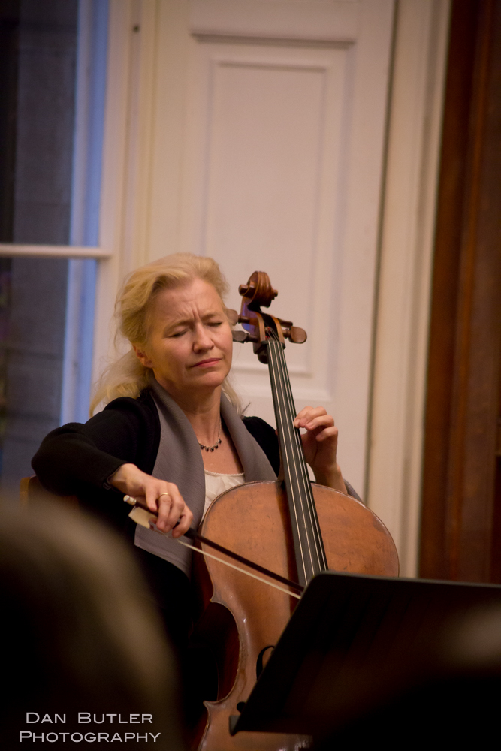
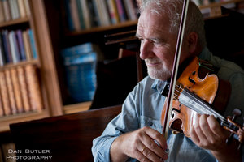For further information please contact us by email at boynemusicfestival@gmail.com or visit www.boynemusicfestival.com
Boyne Music Festival Young Artist Programme 2018 | Application

Ensemble name: ......................................................................................................................
Performer name: Instrument: Date of Birth:
..................................................................... ...................................... ............................
..................................................................... ..................................... ...........................
...................................................................... ...................................... ............................
..................................................................... ..................................... ...........................
...................................................................... ...................................... ............................
Contact details for one ensemble member:
Name: ……................................................... Phone number: ………...................................
Email address: ................................................................................................................................... ............. ......
Home address: ………………………………………………………………………………............................................................. ......
...................................................................................................................................................... ..... ............. ......

Proposed 20 minute concert programme: (You may offer more than one programme)
………………………………………………………………………………………………….............................................................................
………………………………………………………………………………………………….............................................................................
………………………………………………………………………………………………….............................................................................
………………………………………………………………………………………………….............................................................................
Required Supporting Material
Please provide the following additional materials:
- Ensemble biography
- Biography of each member of the ensemble
- A recording of your ensemble (audio or video) – approx. 10 to 15min. in length
Boyne Music Festival
Townley Hall, Slane Road, Drogheda, Co Louth, Ireland
www.boynemusicfestival.com | boynemusicfestival@gmail.com www.facebook.com/BoyneMusicFestival

